**Week – 2 PL/SQL Exercises**

**Schema to be Created**

*CREATE TABLE Customers (*

*CustomerID NUMBER PRIMARY KEY,*

*Name VARCHAR2(100),*

*DOB DATE,*

*Balance NUMBER,*

*LastModified DATE*

*);*

*CREATE TABLE Accounts (*

*AccountID NUMBER PRIMARY KEY,*

*CustomerID NUMBER,*

*AccountType VARCHAR2(20),*

*Balance NUMBER,*

*LastModified DATE,*

*FOREIGN KEY (CustomerID) REFERENCES Customers(CustomerID)*

*);*

*CREATE TABLE Transactions (*

*TransactionID NUMBER PRIMARY KEY,*

*AccountID NUMBER,*

*TransactionDate DATE,*

*Amount NUMBER,*

*TransactionType VARCHAR2(10),*

*FOREIGN KEY (AccountID) REFERENCES Accounts(AccountID)*

*);*

*CREATE TABLE Loans (*

*LoanID NUMBER PRIMARY KEY,*

*CustomerID NUMBER,*

*LoanAmount NUMBER,*

*InterestRate NUMBER,*

*StartDate DATE,*

*EndDate DATE,*

*FOREIGN KEY (CustomerID) REFERENCES Customers(CustomerID)*

*);*

*CREATE TABLE Employees (*

*EmployeeID NUMBER PRIMARY KEY,*

*Name VARCHAR2(100),*

*Position VARCHAR2(50),*

*Salary NUMBER,*

*Department VARCHAR2(50),*

*HireDate DATE*

*);*

**Example Scripts for Sample Data Insertion**

*INSERT INTO Customers (CustomerID, Name, DOB, Balance, LastModified)*

*VALUES (1, 'John Doe', TO_DATE('1985-05-15', 'YYYY-MM-DD'), 1000, SYSDATE);*

*INSERT INTO Customers (CustomerID, Name, DOB, Balance, LastModified)*

*VALUES (2, 'Jane Smith', TO_DATE('1990-07-20', 'YYYY-MM-DD'), 1500, SYSDATE);*

*INSERT INTO Accounts (AccountID, CustomerID, AccountType, Balance, LastModified)*

*VALUES (1, 1, 'Savings', 1000, SYSDATE);*

*INSERT INTO Accounts (AccountID, CustomerID, AccountType, Balance, LastModified)*

*VALUES (2, 2, 'Checking', 1500, SYSDATE);*

*INSERT INTO Transactions (TransactionID, AccountID, TransactionDate, Amount, TransactionType)*

*VALUES (1, 1, SYSDATE, 200, 'Deposit');*

*INSERT INTO Transactions (TransactionID, AccountID, TransactionDate, Amount, TransactionType)*

*VALUES (2, 2, SYSDATE, 300, 'Withdrawal');*

*INSERT INTO Loans (LoanID, CustomerID, LoanAmount, InterestRate, StartDate, EndDate)*

*VALUES (1, 1, 5000, 5, SYSDATE, ADD_MONTHS(SYSDATE, 60));*

*INSERT INTO Employees (EmployeeID, Name, Position, Salary, Department, HireDate)*

*VALUES (1, 'Alice Johnson', 'Manager', 70000, 'HR', TO_DATE('2015-06-15', 'YYYY-MM-DD'));*

*INSERT INTO Employees (EmployeeID, Name, Position, Salary, Department, HireDate)*

*VALUES (2, 'Bob Brown', 'Developer', 60000, 'IT', TO_DATE('2017-03-20', 'YYYY-MM-DD'));*

**Exercise 1: Control Structures**

**Scenario – 1**

**Code:**

DECLARE

v_customer_id Customers.CustomerID%TYPE;

v_dob Customers.DOB%TYPE;

v_age NUMBER;

BEGIN

FOR cust_rec IN (SELECT CustomerID, DOB FROM Customers) LOOP

v_customer_id := cust_rec.CustomerID;

v_dob := cust_rec.DOB;

v_age := FLOOR(MONTHS_BETWEEN(SYSDATE, v_dob) / 12);

IF v_age > 60 THEN

UPDATE Loans

SET InterestRate = InterestRate - 1

WHERE CustomerID = v_customer_id;

DBMS_OUTPUT.PUT_LINE('1% discount applied to CustomerID: ' || v_customer_id);

END IF;

END LOOP;

END;

/

**Output :**

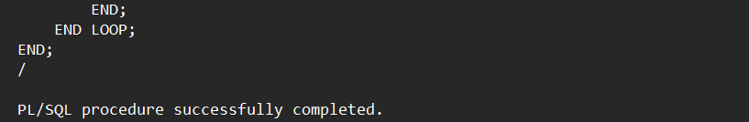

**Scenario – 2**

**Code :**

BEGIN

FOR cust IN (SELECT CustomerID, Balance FROM Customers) LOOP

IF cust.Balance > 10000 THEN

UPDATE Customers

SET IsVIP = 'TRUE'

WHERE CustomerID = cust.CustomerID;

DBMS_OUTPUT.PUT_LINE('VIP status updated for eligible customers');

END IF;

END LOOP;

END;

/

**Output :**

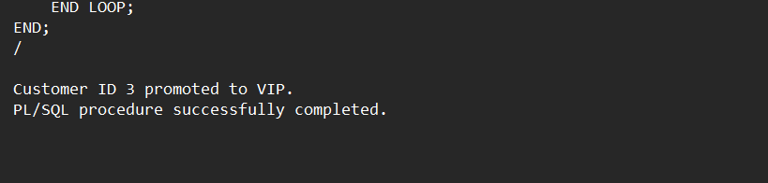

**Scenario – 3**

**Code :**

BEGIN

FOR loan_rec IN (

SELECT L.CustomerID, L.EndDate, C.Name

FROM Loans L

JOIN Customers C ON L.CustomerID = C.CustomerID

WHERE L.EndDate BETWEEN SYSDATE AND SYSDATE + 30

) LOOP

DBMS_OUTPUT.PUT_LINE('Reminder: Loan for ' || loan_rec.Name ||

' is due on ' || TO_CHAR(loan_rec.EndDate, 'DD-Mon-YYYY'));

END LOOP;

END;

/

**Output :**

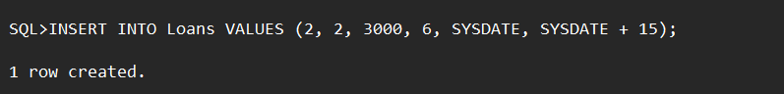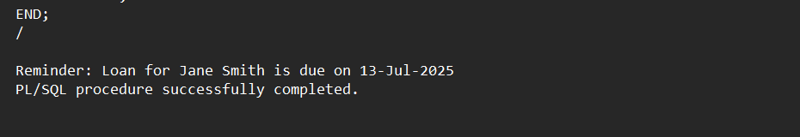

**Exercise 3: Stored Procedures**

**Scenario – 1**

**Code :**

CREATE OR REPLACE PROCEDURE ProcessMonthlyInterest IS

BEGIN

FOR acc IN (

SELECT AccountID, Balance

FROM Accounts

WHERE AccountType = 'Savings'

) LOOP

UPDATE Accounts

SET Balance = Balance + (acc.Balance * 0.01),

LastModified = SYSDATE

WHERE AccountID = acc.AccountID;

DBMS_OUTPUT.PUT_LINE('Interest added to AccountID: ' || acc.AccountID);

END LOOP;

END;

/

**Output :**

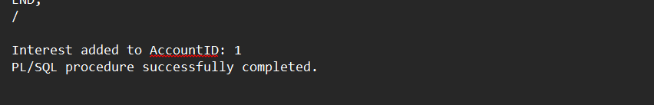

**Scenario – 2**

**Code :**

CREATE OR REPLACE PROCEDURE UpdateEmployeeBonus (

p_dept IN VARCHAR2,

p_bonus_pct IN NUMBER

) IS

BEGIN

FOR emp IN (

SELECT EmployeeID, Salary

FROM Employees

WHERE Department = p_dept

) LOOP

UPDATE Employees

SET Salary = Salary + (emp.Salary * p_bonus_pct / 100)

WHERE EmployeeID = emp.EmployeeID;

DBMS_OUTPUT.PUT_LINE('Bonus updated for EmployeeID: ' || emp.EmployeeID);

END LOOP;

END;

/

**Output :**

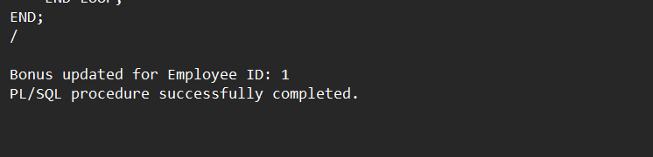

**Scenario – 3**

**Code :**

CREATE OR REPLACE PROCEDURE TransferFunds (

p_source_acc IN NUMBER,

p_target_acc IN NUMBER,

p_amount IN NUMBER

) IS

v_balance NUMBER;

BEGIN

-- Get current balance of source account

SELECT Balance INTO v_balance

FROM Accounts

WHERE AccountID = p_source_acc;

IF v_balance >= p_amount THEN

-- Deduct from source

UPDATE Accounts

SET Balance = Balance - p_amount,

LastModified = SYSDATE

WHERE AccountID = p_source_acc;

-- Add to target

UPDATE Accounts

SET Balance = Balance + p_amount,

LastModified = SYSDATE

WHERE AccountID = p_target_acc;

DBMS_OUTPUT.PUT_LINE('Transfer successful from Account ' || p_source_acc ||

' to Account ' || p_target_acc);

ELSE

DBMS_OUTPUT.PUT_LINE('Transfer failed: Insufficient balance in Account ' || p_source_acc);

END IF;

EXCEPTION

WHEN NO_DATA_FOUND THEN

DBMS_OUTPUT.PUT_LINE('One or both accounts not found.');

WHEN OTHERS THEN

DBMS_OUTPUT.PUT_LINE('Error: ' || SQLERRM);

END;

/

**Output :**

